COMMIS
S
ION RATE CARD
Effective
1
st

J
anuary

201
9

COMMISSION RATE CARD – Advisory Only Services - Effective 1st January 2019

Annual Fee charges:  Administration Fee  Advisory Fee  QFM fee - ARF & AMRFs  Additional PMA Account Administration Charge  Cash interest charged on EUR balances | Details/Charges:  Portfolio charge of up to 0.75% subject to a minimum charge of €375 per annum.  Fee charge of up to 0.25% subject to a minimum charge of € 125 per annum + VAT.  Additional portfolio charge of up to 0.50% + VAT.  Additional flat fee €200 + VAT  Cash balances with a euro value greater than €5,000, held for 1 month, may attract an interest charge of 0.45% per annum.
Application of Fees | From time to time arrears of fees may arise (i.e. for those accounts with insufficient cash to cover the fees). When the relevant account subsequently comes into a positive cash position Cantor Fitzgerald Ireland Limited reserves its right to apply the fee arrears at that time. In addition, Section 12 of our Terms & Conditions permits Cantor Fitzgerald Ireland Limited to dispose of any investment held for you to reduce or eliminate any liability arising from arrears of fees.

Transactional charges: |  | Details/Charges
Equity/Investment Funds | Commission Charges: | €0 - €20,000 1.50% €20,001 - €40,000 1.00%  Balance 0.50%  Minimum € 55
 | Contract Fee: | Irish/UK Nominee (Crest) € 40 Certificated and All Others € 60
Fixed Income Securities | Commission Charges: | € 0 - € 100,000 0.50%  Balance 0.25%  Minimum € 55
 | Non Irish Sovereign Fixed Income Securities (On Nominal): | AAA Bonds rate by S&P* 0.05%  All other Bonds 0.25%  *Or equivalent rating agency if S&P unavailable
 | Contract Fee: | € 60
PTM Levy  IPT Levy  Currency Conversion | Charged on any transaction of UK Securities exceeding £10,000 STG - £1.00  Charged on any transaction of Irish Securities exceeding €12,500 - €1.25  Transactions denominated in a currency other than the currency in which they are to be settled, will be settled based on the prevailing spot exchange rate on the day of the transaction, plus a margin (up to a maximum of 1%)
Subject to scale discounts dependant on the overall size and nature of your account.
Other: | Details/Charges:
Government Stamp Duty | Applied to purchases of Irish & UK shares and Irish domicile funds.  1.00% Irish equities (excluding companies listed on the  Enterprise Securities Market of the Irish Stock Exchange) & 0.5% UK Equities
Same Day Bank Transfer | € 20
Stock Transfer Out / Certificate Out – Irish/UK | € 25 per Stock
Stock Transfer Out / Stock Certificate/DRS Statement Out – Foreign | € 75 per Stock
Certificate Lodgement to a Nominee A/c – Irish/UK, Other | € 15 per Certificate (Irish/UK), € 30 per Certificate (Other)
Pershing charge – US based clients | €1,200 per month
Traded Options/CFDs | Charged separately by agreement.
Please note that all fees and charges above are exclusive of VAT, which shall be charged (where applicable) at the rate in force at the fata the tax falls due.

PAGE 1

Illustration of potential cost & charges
-

Advisory Services

This document discloses potential costs and charges information about your investments with Cantor Fitzgerald Ireland. This illustration is required by law and you are advised to review it so you can make decisions on your investments.

The following standard charges are applicable for normal trading activity:

- Administration fee rate – 0.75% (minimum €375)
- Advisory fee – 0.25% (minimum €125) + VAT
- Cash Management charge - 0.45% on balances over €5,000 • Commission charges: o €0 - €20,000 – 1.50% o €20,001 - €40,000 – 1.00% o Balance – 0.50% o Minimum - €55
- Contract fee o €40 Irish & UK o €60 All Other & certificated
- Government stamp duty on purchases o 1% Irish equities o 0.50% UK equities

Below are the estimated annualised costs for an account based on 1 trade of €100,000 in Irish equity. The total portfolio value - €100,000.

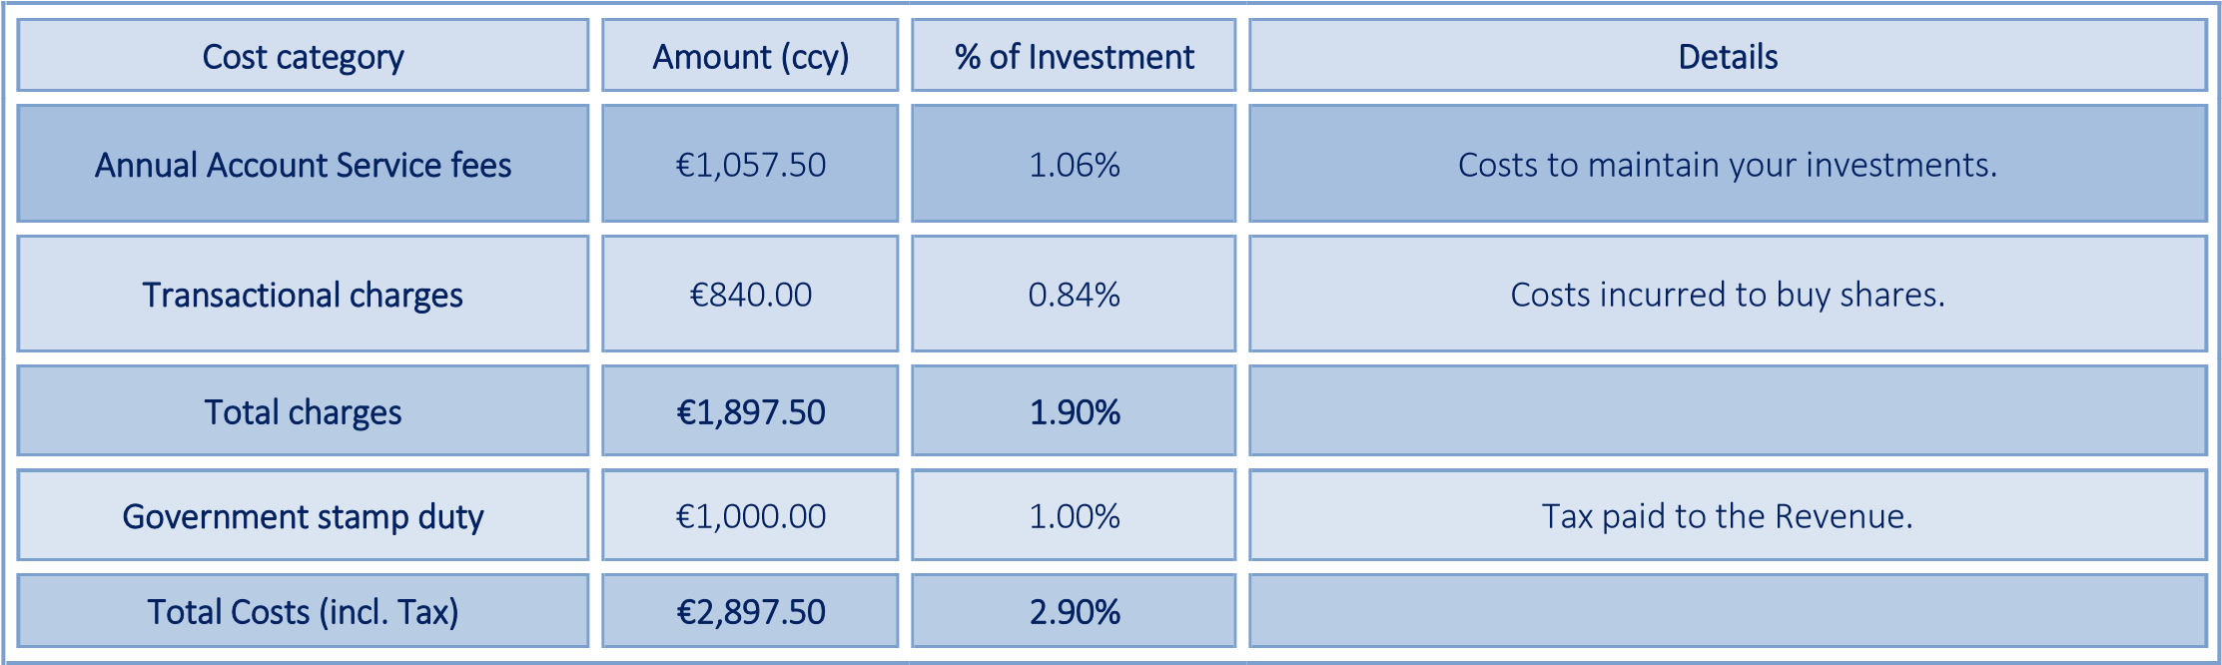

DUBLIN: 75 St. Stephen’s Green, Dublin 2, Ireland. Tel: +353 1 633 3800. Fax: +363 1 633 3856/+353 1 633 3857
CORK: 45 South Mall, Cork. Tel: +353 21 422 2122
LIMERICK: Theatre Court, Lower Mallow Street, Limerick. Tel: +353 61 436500

email: Ireland@cantor.com web: www.cantorfitzgerald.ie

Cantor Fitzgerald Ireland Ltd is regulated by the Central Bank of Ireland. Cantor Fitzgerald Ireland Ltd is a Member Firm of The Irish Stock Exchange and The London Stock Exchange.

PAGE 2

